

**Report of the compiler first project**   
Professor:  
 Dr. Shirali shahreza  
Teaching Assistants:   
Parnian Hatami

Student:  
 Mohammadreza Ardestani **(**[**ardestani.zr@gmail.com**](mailto:ardestani.zr@gmail.com)**)**

20,Nov,2020

0) **Introduction**  
Phase 1) **About code**Phase 2) **Output format**

**0) Introduction**This report will be concise but thorough. If you need more detail, please contact me.  
**How to run:**

1. Copy input file in the project directory and name it “txt.txt” .
2. Run project.
3. Now you can receive the project result in “output.txt”.

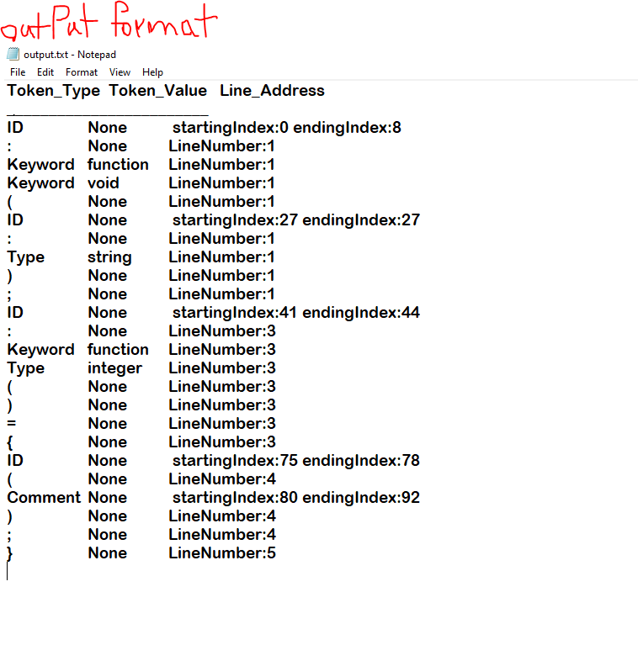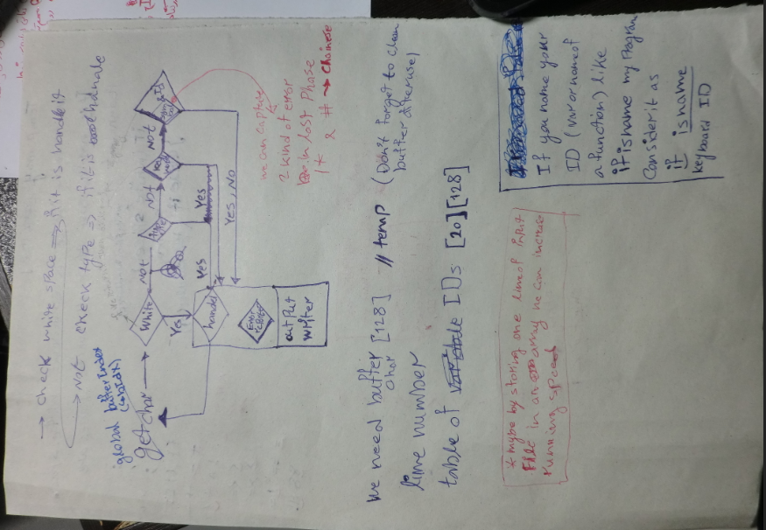

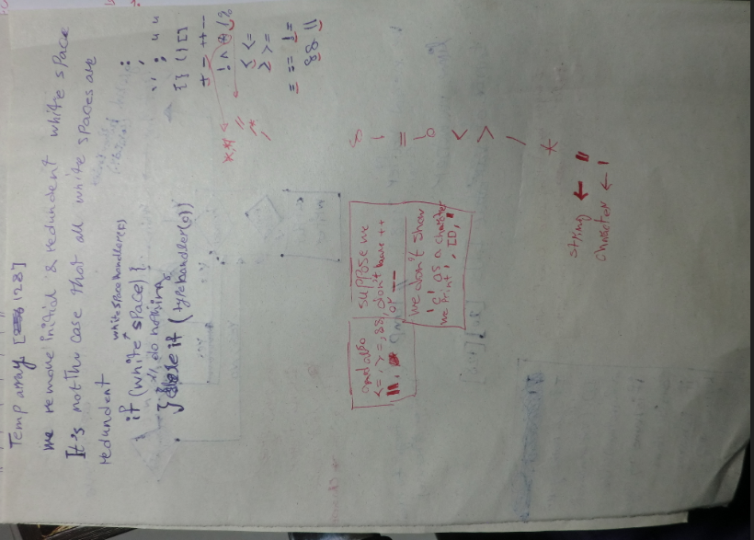

Thanks for your time.